

Assessment Cover Page

Student Full Name: | Andrea Diaz Medrano
Student Number: | 2026627
Module Title: | Strategic Thinking
Assessment Title: | CA 1 – Capstone Project Proposal
Lecturer/Supervisor: | Taufique Ahmed
Assessment Due Date: | 21-09-2026
Date of Submission: | 25-10-2026

Contents
I. Project Title 1
II. Introduction 2
III. Problem Definition 3
IV. Aim and Objectives 3
V. Scope 4
VI. Methodology 4
VII. Data Sources 5
VII. Expected Deliverables 6
IX. Project Timeline 6
X. Ethical and Legal Considerations 6
XI. References 7
XII. Appendix 8

I. Project Title
Predictive Analytics for manufacturing sector greenhouse gas (GHG) emissions: Supporting Strategic Sustainability Decision-Making.

II. Introduction
The CO₂ is a gas that forms part of the atmosphere’s natural composition, and its presence is a vital part of Earth’s carbon cycle (Environmental Protection Agency (EPA), 2026), as shown in Figure 1 below.
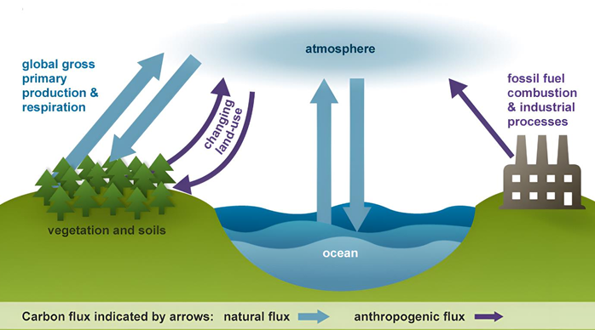
Figure 1. Carbon cycle (Habeeb and Al-Husseini, 2024).
The cycle is usually thought of as four main reservoirs which are the atmosphere, terrestrial biosphere (usually includes freshwater systems), oceans, and sediments (includes fossil fuels) (Environmental Protection Agency, 2013).
However, human activities, particularly those related to the industrial processes, have disrupted this balance by increasing the concentration of GHG, such as CO₂, water vapor (H₂O), methane (CH₄), nitrous oxide (N₂O), ozone (O₃), and fluorinated gases such as CFCs.
Currently, corporations have a vital role to play in efforts to mitigate global warming as the dominant producers of industrial GHG emissions (Downie and Stubbs, 2013). These emissions can be quantified using GHG inventories, which may include Scope 1, Scope 2 and Scope 3 emissions (described below in Figure 2) and expressed in tCO₂e.
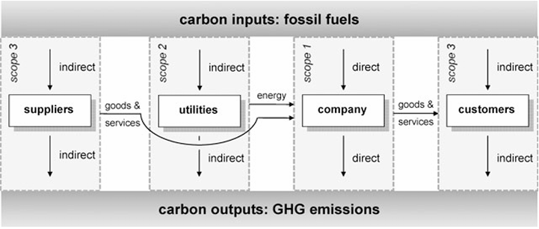
Figure 2. GHG emissions (Timo, 2008).
Due to the European Commission’s announcement of its intention to reduce net GHG emissions by at least 55% by 2030 compared to 1990 levels (Kasperzak and Kerschbaumer, 2023) the measures to reduce GHG emissions have become even more relevant. These regulatory frameworks include the Greenhouse Gas Protocol (GHG Protocol) and the European Union’s Corporate Sustainability Reporting Directive (CSRD), to name a few.
However, historical GHG emissions reports alone do not necessarily provide sufficient information to support forward-looking decision-making. Organizations must also understand how their emissions may evolve under different business and operational conditions.
This environmental data can be used to identify patterns and relationships between corporate characteristics and GHG emissions. This presents an opportunity for data analysis and the development of predictive models to estimate future emissions.

III. Problem Definition
The problem addressed by this project is predicting future GHG emissions using historical GHG emissions data from companies in the manufacturing sector, with aim of developing alternatives and measures aimed at managing and reducing the environmental impact of business activities.

IV. Aim and Objectives
Aim
- To determine whether historical GHG emissions data can be used to predict future emissions and provide information to support strategic planning for reduction measures in the manufacturing sector.
Objectives:
- To collect, clean and integrate relevant historical corporate and GHG emissions of manufacturing sector.
- To analyse historical patterns and relationships between corporate characteristics, such as revenue or number of employees, and GHG emissions generated, for manufacturing sector.
- To develop and evaluate a predictive model using relevant historical corporate and GHE emissions of manufacturing sector.

V. Scope
Only data from the manufacturing sector will be considered. The project will be based on GHG emissions, traying to cover only Scopes 1 and 2; Scope 3 will be entirely excluded (depending on the availability of the data). However, this is going to depend on the quality and quantity of data found.

VI. Methodology
The project will use a data analysis and predictive modelling approach to investigate whether historical corporate and environmental data can be used to predict future GHG emissions at manufacturing companies. The methodology to be followed will be as follows:
- Data collection and preparation.
The data will be collected, cleaned and prepared to identify missing values, duplicate records or differences in units of measurement. The final selection of variables (such as, revenue or number of employees) will depend on their availability, quality and consistency.
- Exploratory data analysis.
An exploratory data analysis will be conducted using descriptive statistics, visualization and correlation analysis. The main objective will be to identify patterns in emissions and explore the relationships between emissions and company characteristics. This analysis will also allow us to define the mean, median, standard deviation, minimum and maximum values as well as the identification of missing and outlier values.
- Predictive modelling
In this first approach, the idea is to use a supervised learning method since the dataset will include known historical GHG emission values that can be used to train and evaluate the model.
Since the goal is to estimate future values of GHG emissions a regression model is proposed. Linear regression will be considered because of its usefulness in analysing the relationship between the available corporate variables and emissions additionally the review of the academic literature has made it possible to identify the use of regression techniques in prediction and emissions analysis studies, which provides a basis for considering this approach in the current project (Habeeb and Al-Husseini, 2024). However, the final choice of model will depend on the quantity, quality, and temporal structure of the collected data.
- Model evaluation and interpretation.
According to the literature, metrics such as Mean Absolute Error (MAE), Mean Squared Error (MSE), R-squared (R²), and adjusted R-squared (Adj-R²) can be used for regression models. For the purposes of this project, we will use Mean Squared Error (MSE) and R-squared (R²), as their use has already been reported in similar projects (Habeeb and Al-Husseini, 2024).
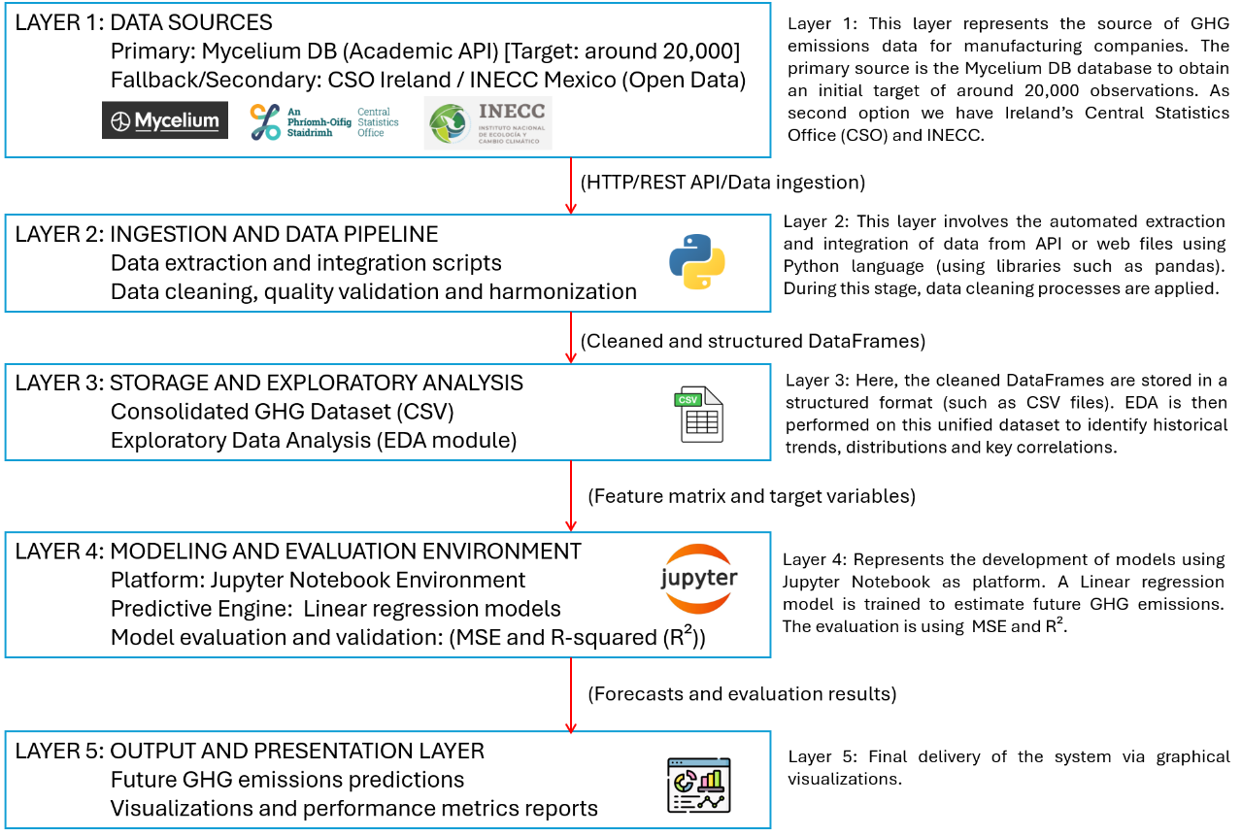
Figure 3. High-level architectural diagram.

VII. Data Sources
The primary data source will be the Mycelium (Mycelium, n.d.) database, which provides academic API access for research purposes. The project will aim to obtain approximately 20,000 observations of GHG emissions of manufacturing companies. However, this target will depend on the availability, quality and variety of the data obtained (therefore, the total value could be higher or lower).
If Mycelium does not provide sufficient suitable data, alternative sources will be considered, including Ireland’s Central Statistics Office (CSO, 2026) and Mexico’s National Institute of Ecology and Climate Change (INECC, 2026). Which data access is free.

VII. Expected Deliverables
By the end of Semester 2, the project is expected to deliver:
- A cleaned and integrated dataset containing historical GHG emissions data for the manufacturing sector, along with relevant corporate characteristics where available.
- An exploratory data analysis report identifying historical emissions patterns and relationships between emissions and business growth indicators such as revenue and number of employees.
- A predictive model developed in Jupyter Notebook to estimate future GHG emissions accompanied by an evaluation of its predictive performance using appropriate metrics.
- A final project report presenting results, limitations and potential implications of the findings for strategic sustainability planning.

IX. Project Timeline
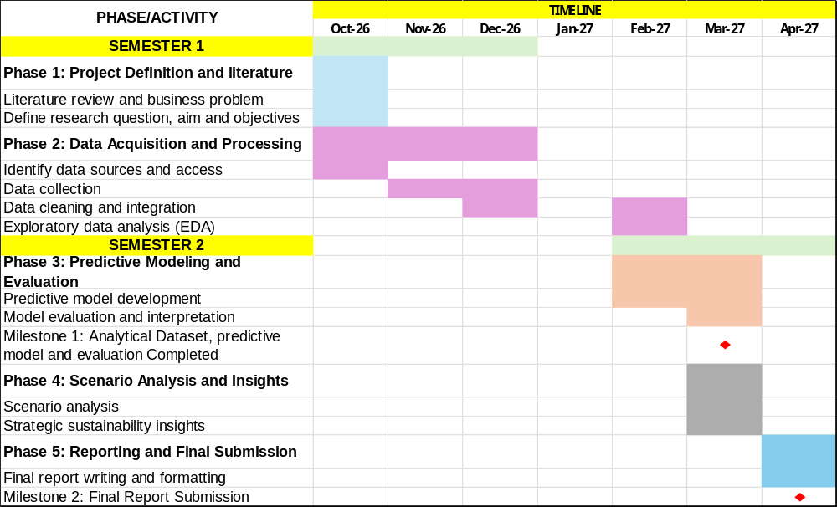
Figure 4. High-level project timeline diagram.

X. Ethical and Legal Considerations
The project exclusively processes corporate-level GHG emissions and organizational metrics. No personal identifiable information or personal data of individuals will be collected, which minimizes direct constraints related to General Data Protection Regulation (GDPR) compliance.
Access to the primary source (Mycelium) is authorized via an official academic API. Access to secondary sources (CSO Ireland and INECC Mexico) will be facilitated through open data frameworks. APIs keys will never be hardcoded into scripts or committed to the institutional repository. All stages of this project will be documented in detail within Jupyter Notebook.

XI. References
Central Statistics Office (CSO) (2026). EAA17: Greenhouse Gas Emissions. Available at: https://data.cso.ie/table/EAA17 (Accessed: 17 October 2026).
Downie, J. and Stubbs, W. (2013). “Evaluation of Australian companies’ scope 3 greenhouse gas”, Journal of Cleaner Production. Available at: https://doi.org/10.1016/j.jclepro.2011.09.010 (Accessed: 02 October 2026).
Environmental Protection Agency (EPA) (2013). Climate Change Terms. Available at: https://sor.epa.gov/sor_internet/registry/termreg/searchandretrieve/glossariesandkeywordlists/search.do?details=&vocabName=Glossary%20Climate%20Change%20Terms&filterTerm=carbon%20cycle (Accessed: 06 October 2026).
Environmental Protection Agency (EPA) (2026). Greenhouse Gas Emissions: Carbon Dioxide Emissions. Available at: https://www.epa.gov/ghgemissions/carbon-dioxide-emissions (Accessed: 06 October 2026).
Habeeb, F.A. and Al-Husseini, A.H. (2024). “Global Analysis and Prediction of CO2 and Greenhouse Gas Emissions across Continents”. Available at: https://doi.org/10.58496/ADSA/2024/014 (Accessed: 28 September 2026).
Instituto Nacional de Ecología y Cambio Climático (INECC) (2018). Inventario Nacional de Emisiones de Gases y Compuestos de Efecto Invernadero. Available at: https://www.gob.mx/inecc/acciones-y-programas/inventario-nacional-de-emisiones-de-gases-y-compuestos-de-efecto-invernadero (Accessed: 19 October 2026).
Kasperzak, R. and Kerschbaumer, M. (2023). “Accounting for Carbon Emissions—Current State of Sustainability Reporting Practice under the GHG Protocol”, Sustainability, 15(2), p. 994. Available at: https://www.mdpi.com/2071-1050/15/2/994 (Accessed: 15 October 2026).
Mycelium Network (n.d.) Mycelium Network. Available at: https://api.mycelium.global/docs/v1 (Accessed: 19 October 2026).
Timo, H.H. (2008). “Corporate Carbon Performance Indicators: Carbon Intensity, Dependency, Exposure and Risk”, Journal of Industrial Ecology, pp. 505-520.

XII. Appendix
Use of AI Tools
I acknowledge the use of Chat GPT and Google Gemini for the purpose of get a possible dataset sources, Gantt diagram, high-level architectural diagram and to format references according to Harvard style respectively.

Declaration
By submitting this assessment, I confirm that I have read the CCT policy on academic misconduct and understand the implications of submitting work that is not my own or does not appropriately reference material taken from a third party or other source.
I declare it to be my own work and that all material from third parties has been appropriately referenced.
I further confirm that this work has not previously been submitted for assessment by myself or someone else in CCT College Dublin or any other higher education institution.

AI Declaration using the AI Fluency Framework
AI competence | Reflective prompts (to students) | Lecturer expectations | Student response
Delegation  Deciding whether & when to use AI | Identify the specific tasks in this assessment where you chose to use AI, and explain your reasoning. Where did AI add value? Where did you decide not to use it, and why? | You may use AI to support your learning and development of the application. Clearly identify where you used AI and where you completed the work independently. | In the “data sources” section, I used Chat GPT to help me find different online databases of corporate-level GHG emissions, which streamlined the search process.  In the “Project timeline” I used CHAT GPT to create an example of Gantt diagram.  In the section “High-level architectural diagram” I used Google Gemini, I uploaded my diagram and asked whether it was considered a correct High-level architectural diagram.  In the “References” section, I used Google Gemini to help format my references according to the Harvard style, as my version of Word does not include this citation style.
Description  How you prompted the AI | Include the exact prompts you used in your appendix (recorded on the AI Tools declaration). Reflect on how you communicated your goals to the AI — did you need to iterate or refine your prompts to get useful output? | You must provide the exact prompts and relevant AI outputs used during the development of your application. | For Chat GPT I used these prompts:  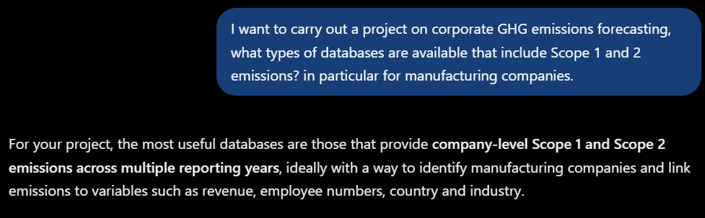  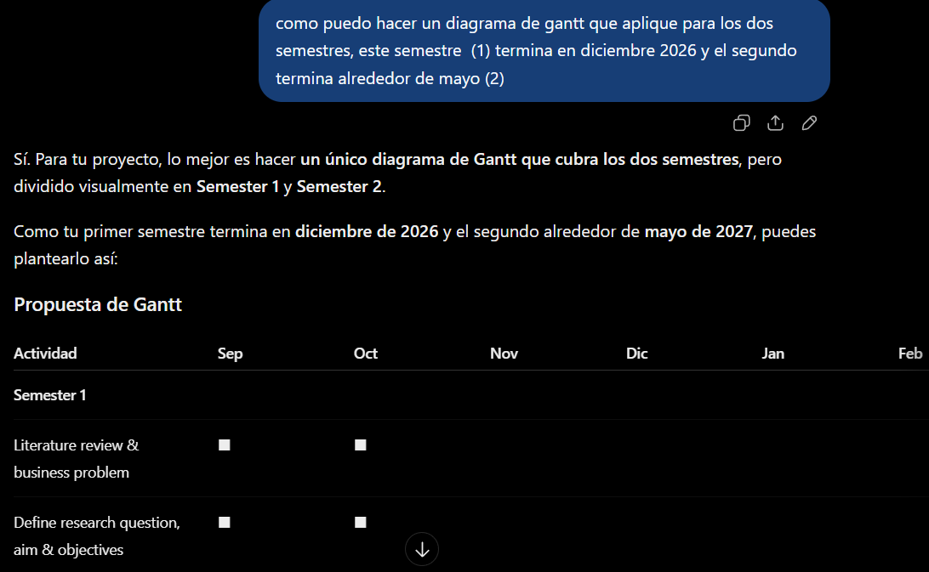  NOTE: This prompt was in Spanish, I request on Chat GPT “How can I make a Gantt chart that applies to both semesters? This semester (1) ends in December 2026, and the second one ends around May (2)”  For Google Gemini I used these prompts:    NOTE: I did this prompt in Spanish: I asked “Do you consider this diagram a high-level architectural diagram?”.  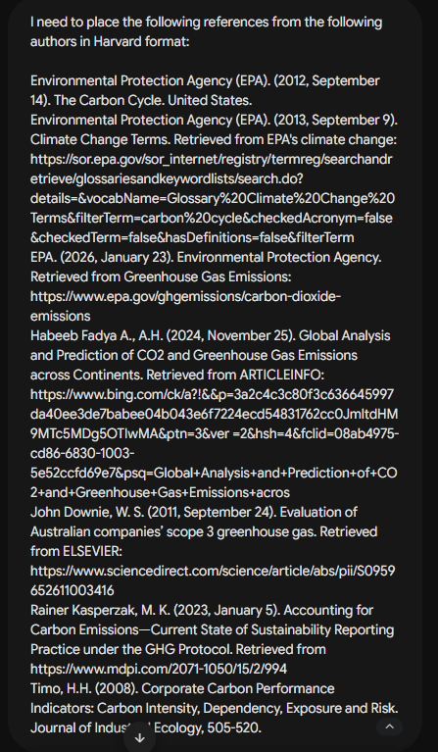
Discernment  Evaluating what the AI produced | In your reflection, critically evaluate the AI output: what did you accept, modify, or reject — and why? Assess accuracy, relevance, and quality. You are responsible for verifying all AI-generated content before submitting. | You are responsible for checking, testing and understanding any AI-generated code or suggestions before using them in your work. | For the “Data sources”, I identified Mycelium as the database best suited for my project. However, I also decided to look for two additional sources, as a backup in case the option suggested by Chat GPT fails to provide the target number of observations.  For the Gantt diagram I modified the diagram according to the project activities, dates and important milestones of it.  Regarding to the High-level architectural diagram, I looked for more information in the literature. However, I do find that this AI tool helped me better understand how to create a diagram of this type.  Regarding the references section, I verified that citations provided by Google Gemini were accurate and ensured that only those referenced within the document were included. I used the following link to confirm the Harvard style. https://library.cct.ie/ld.php?content_id=35451126
Diligence  Responsibility for your AI use | Declare all AI tools used and cite them here. Briefly outline how you considered data protection, copyright, and ethical responsibilities when choosing what to input into any AI system. Unauthorised use is subject to CCT disciplinary procedures. | Declare all AI tools used. Do not enter personal, confidential or sensitive information into AI tools. Any external sources used should be appropriately referenced. | Chat GPT and Google Gemini. In none of my prompts did I use personal or academic information that could compromise my document.

Adapted from the AI Fluency Framework (Dakan, Feller, Anthropic, 2025).

